Holmewood & District Internal Drainage Board Biodiversity Action Plan Report 2013-14

Drainage Ditch Action Plan
Target Reference | Target | Action Reference | IDB Actions | Partners | Date | Indicators | Report
1 | Manage ditches for biodiversity as well as for drainage | 1.1 | Establish and maintain a management plan for routine IDB operations incorporating key biodiversity features | Environmental Officer | 2015 | Plan finalised and followed each year | A map-based plan is in the process of establishment.
1 | Manage ditches for biodiversity as well as for drainage | 1.2 | Look for opportunities to provide natural erosion protection such as marginal plant ledges when re-profiling ditches | Environmental Officer | Ongoing | If re-profiling is carried out, opportunities identified | No appropriate sites for this method were identified during the period.
1 | Manage ditches for biodiversity as well as for drainage | 1.3 | Provide natural erosion protection as in 1.2 if opportunities available | Environmental Officer | Ongoing | Length of ditch with ledge / natural vegetation revetment | |As above.
2 | Identify ditches of conservation interest and manage appropriately | 2.2 | Ensure appropriate management of ditches for priority species | Environmental Officer, Plantlife, Wildlife Trust | Ongoing | Specified in management plan | Any priority ditches will be identified as the management plan map is developed.
3 | Support the Environmental Officer in working with landowners to benefit wildlife in the district | 3.1 | Refer private landowners to the Environmental Officer for advice on creating field margin buffer zones and wildlife-friendly ditch management | Environmental Officer, Natural England, Wildlife Trust, FWAG | Ongoing | Number of contacts received and passed to Environmental Officer | No formal contacts received.
4 | Control invasive species | 4.1 | Report any sightings of non-native invasive species immediately to the Environmental Officer and control as appropriate (see Appendix F for species list) | Environmental Officer, Environment Agency, Plantlife, Wildlife Trust | Ongoing | Reports to Environmental Officer | No invasive species recorded.
5 | Plant black poplars to increase existing population | 5.1 | Identify suitable sites and plant at least 2 young black poplars | Environmental Officer | 2015 | Number of trees planted | 10 black poplars planted, 1 at Herbert’s Bridge, 2 at Frogs Hall Bridge, 7 at Corney’s Farm on 07/04/14.

Reedbed Action Plan
Target Reference | Target | Action Reference | IDB Actions | Partners | Date | Indicators | Report
1 | Identify, assess and map any areas of reedbed over 0.5ha in size | 1.1 | Pass details of any known areas to MLC Environmental Officer | Wildlife Trust, Natural England, Environment Agency | 2012 | Review of reedbed areas carried out | No areas of reedbed over 0.5ha identified.
2 | Support appropriate reedbed creation | 2.1 | Liaise with major habitat creation projects such as the Great Fen and gravel pit restorations | Natural England, Wildlife Trust, RSPB, WWT, Environment Agency | Ongoing | Formal contact made with project | As a Partner in the Great Fen Project the Middle Level Commissioners Engineers are involved with planning for flood event storage in the Great Fen area.
2 | Support appropriate reedbed creation | 2.2 | Manage the District adopted drains, where possible, to assist private landowners who wish to create areas of reedbed on their own land | Wildlife Trust, Environment Agency | Ongoing | (a) Number of requests received  (b) Number of landowners assisted | No approaches received, apart from ongoing Great Fen Project.
3 | Take conservation value of reedbed into account when planning and carrying out ditch and river maintenance | 3.2 | Where reeds are present, commence mowing or cleansing work outside the bird breeding season (7th April – 15th July). | Environmental Officer, Wildlife Trust, RSPB | Ongoing | Reeds not cut during bird nesting season | Reeds were not cut during bird nesting season.

Fen Action Plan
Target Reference | Target | Action Reference | IDB Actions | Partners | Date | Indicators | Report
1 | Identify, assess and map areas of existing fen habitat | 1.1 | Pass details of any known areas to Environmental Officer | Wildlife Trust, Natural England, Environment Agency | 2013 | Review of potential fen areas carried out | Potential fen areas identified by Great Fen Project
3 | Support conservation measures for existing major fen sites | 3.1 | Contribute to implementation of WLMP for Woodwalton Fen and Holme Fen | Natural England, Environment Agency, Wildlife Trust | Ongoing | WLMP actions implemented where within IDB’s control | Water Level Management Plans in hand by the conservation partners of the Great Fen Project.

Open Water Acton Plan
Target Reference | Target | Action Reference | IDB Actions | Partners | Date | Indicators | Report
1 | Promote the creation of ponds, lakes and reservoirs in appropriate areas | 1.1 | Consider pond creation as mitigation when a ditch has to be filled in or culverted | Local authorities, Amphibian & Reptile Conservation, Wildlife Trust | Ongoing | (a) Number of mitigation opportunities (b) Number of ponds created | (a) No ditch infilling occurred, (b) No pond creation opportunities in mitigation available.
1 |  | 1.2 | Support creation of flood storage areas and reservoirs | Environment Agency, Natural England, Wildlife Trust, RSPB | Ongoing | Number of projects involved with | One. Flood storage within the Great Fen Project discussions on-going.
1 |  | 1.3 | Assist private landowners with advice, information or contacts as necessary | Amphibian & Reptile Conservation, Wildlife Trust | Ongoing | (a) Number of information requests  (b) Number responded to | (a) No formal information requests received, (b) no responses required.
2 | Look for opportunities to create open water habitat when managing ditches | 2.1 | Create a pool at an appropriate ditch junction when re-profiling (see the Drainage Channel Biodiversity Manual, technique CL3)) | Environmental Officer | 2010 | One pool successfully created | No opportunities for this action were identified during the period.

Water Vole Action Plan
Target Reference | Target | Action Reference | IDB Actions | Partners | Date | Indicators | Report
1 | Manage ditches according to the law and to best practice for water vole | 1.1 | Assume water voles are present when carrying out works (discuss special circumstances with the Environmental Officer) and follow the ADA water vole mitigation guide | Environmental Officer | Ongoing | Measures incorporated in management plans | Water vole friendly ditch maintenance practices were adhered to.
1 |  | 1.2 | Publicise good practice for rat control near drainage ditches | Environmental Officer, Wildlife Trust | Ongoing | Good practice publicised | Good practice for rat control was publicised via the Environmental Officers newsletter issue 5.
2 | Enhance drainage ditch habitat to benefit water vole | 2.1 | Look for opportunities to add a marginal shelf when re-profiling banks | Environmental Officer | Ongoing | (a) Opportunities identified  (b) Measures taken | (a) No opportunities identified during the period  (b) No measures taken.
2 | Enhance drainage ditch habitat to benefit water vole | 2.2 | Consider using coir roll to stabilise banks and provide marginal vegetation | Environmental Officer | Ongoing | (a) Sites considered  (b) Measures taken | No appropriate sites for this measure identified.
3 | Monitor water vole populations | 3.1 | Set up a survey programme to monitor water vole populations | Environmental Officer, Wildlife Trust | 2010 | Surveys carried out | Informal surveys are carried out by the EO. Surveys also carried out by the Great Fen Project. Indications are that numbers have had a resurgence, especially in the Yaxley area of the District.
3 | Monitor water vole populations | 3.2 | Provide data on water vole to the relevant Biological Records Centres | Environmental Officer, CPBRC, NBIS | Ongoing | Data sent via Environmental Officer annually | Records passed to Environmental Records Centre.
4 | Control mink as necessary | 4.2 | Carry out mink control as part of the Middle Level programme and report all sightings to the Environmental Officer | Environmental Officer | Ongoing | (a) Number of trapping days  (b) Number of mink caught | Mink trapping volunteers sought within the District. Traps, training, support available from Environmental Officer

Otter Action Plan
Target Reference | Target | Action Reference | IDB Actions | Partners | Date | Indicators | Report
1 | Improve otter habitat | 1.1 | Identify and maintain existing key bushes and trees near watercourses likely to be important for otters | Environmental Officer | 2012 and ongoing | Sites identified and listed in management plans | Any key bushes and trees will be identified as the management plan is developed.
2 | Monitor otter populations | 2.3 | Ensure any dead otters are reported to the Environmental Officer and transferred to the Environment Agency for post mortem | Environment Agency | Ongoing | Otters reported to Environmental Officer, if found | No dead otter were reported in the district. Otter signs have regularly been recorded throughout the district. Sightings have been more frequent, a female with young seen at Holmewood Fen and a single otter seen near Corney’s Farm.
3 | Reduce otter deaths related to eel and crayfish trapping and road traffic | 3.1 | Report incidents of suspected illegal netting, trapping or fishing to the Environment Agency Fisheries Officers and the MLC Environmental Officer | Environment Agency, Angling Clubs & syndicates | Ongoing | Incidents reported, if discovered | No illegal netting incidents recorded

Bats Action Plan
Target Reference | Target | Action Reference | IDB Actions | Partners | Date | Indicators | Report
1 | Improve habitat for bats | 1.1 | Put up at least 3 bat boxes at appropriate sites, e.g. pumping stations | Bat Conservation Trust | 2015 | Number of bat boxes sited | 2 bat boxes previously installed at Whittlesey Mere & Yaxley Fen Pumping Stations. A site for one further box is sought in the District.
1 | Improve habitat for bats | 1.2 | Pollard suitable trees to provide bat roosts |  | Ongoing | Number of trees pollarded | Five plus willows at Corney’s Farm were pollarded & coppiced during the period.
1 | Improve habitat for bats | 1.3 | Identify potential sites for a bat hibernaculum, e.g. in disused buildings or tunnels | Environmental Officer , Bat Conservation Trust | As opportunities arise | (a) Potential sites looked for (b) Site created | To be considered during management plan creation.
2 | Collect information on bat populations | 2.1 | Monitor bat boxes | Bat Conservation Trust | 2015 onwards | (a) Number of boxes monitored  (b) Number of boxes used by bats | (a) 2 boxes checked, Whittlesey Mere & Yaxley Fen PS  (b) No signs of use. It can take time for bats to adopt provided boxes.
2 | Collect information on bat populations | 2.2 | Pass bat box information to CPBRC and NBIS | Environmental Officer, CPBRC, NBIS | 2015 onwards | Data via Environmental Officer annually | Annual, when data available.

Kingfisher Action Plan
Target Reference | Target | Action Reference | IDB Actions | Partners | Date | Indicators | Report
1 | Improve the quality of kingfisher habitat | 1.1 | Provide at least 3 potential nest holes in sheet pilings | Environmental Officer | Ongoing | Number of nest sites provided | 1 potential kingfisher hole drilled at Yaxley Fen PS on 30/05/14.
1 | Improve the quality of kingfisher habitat | 1.2 | Leave kingfisher fishing perches where possible (e.g. occasional branch) | Environmental Officer | Ongoing | Number of perch sites left | Many natural perches present within the district.
2 | Collect records of kingfisher breeding between March and July | 2.1 | Note sightings of potential breeding kingfisher and pass information to CPBRC and NBIS via the Environmental Officer | Environmental Officer, CPBRC, NBIS | Ongoing | Data sent via Environmental Officer annually | Kingfishers breeding near Herbert’s Bridge. Data sent.

Barn Owl Action Plan
Target Reference | Target | Action Reference | IDB Actions | Partners | Date | Indicators | Report
1 | Improve the quality of barn owl habitat | 1.1 | Put up at least 4 barn owl nest boxes in suitable locations | Wildlife Conservation Partnership | 2015 | Number of nest boxes provided | 2 barn owl boxes previously installed at Whittlesey Mere & Yaxley Fen Pumping Stations. Suitable locations sought for 2 further Board boxes.
1 | Improve the quality of barn owl habitat | 1.2 | Pollard suitable trees to provide natural nest sites | Environmental Officer | Ongoing | Number of trees pollarded | A riverside ash tree at Corney’s Farm was pollarded during the period.
2 | Collect records of barn owl presence | 2.1 | Monitor nest boxes for use.  Have occupied boxes checked for success by licensed barn owl ringers. | Wildlife Conservation Partnership | 2015 | (a) Number of nest boxes checked by licensed ringers  (b) Number of nest boxes used | (a) 2 boxes checked. (b) 2 boxes used. Barn owls with young at Whittlesey Mere PS, May 2014. A pair of kestrels nesting in the Yaxley Fen PS box, May 2014.
2 | Collect records of barn owl presence | 2.2 | Pass barn owl box information to CPBRC and NBIS | Environmental Officer, Wildlife Conservation Partnership, CPBRC, NBIS | 2015 | Data sent via Environmental Officer annually | Data will be sent.

Procedural Action Plan
Target Reference | Target | Action Reference | IDB Actions | Partners | Date | Indicators | Report
1 | Provide training on IDB BAP and conservation management of drainage channels for all relevant staff by 2013 | 1.1 | Establish programme of 1-day courses for IDB staff and members | Environmental Officer, Wildlife Trust, Natural England, other specialists | 2013 | (a) Number of courses held  (b) Number of Board members / staff attending courses | 1 meeting, IDB Officers BAP meeting on 04/12/13. Russell Wright attended. Other board members welcomed. Next meeting Wens 3rd Dec 2014.
1 |  | 1.2 | Establish suitable training for contractors’ staff | Environmental Officer, Contractors | 2013 | Contractors attended training course | No training courses held.
2 | Take biodiversity into account when planning and undertaking capital works | 2.1 | Consult with the Environmental Officer and choose the best possible mitigation solutions for biodiversity, e.g. fish-friendly pumps | Environmental Officer | Ongoing | (a) Number of capital schemes undertaken  (b) Number of schemes commented on | (a) No capital schemes undertaken by the Board  (b) No schemes commented on.

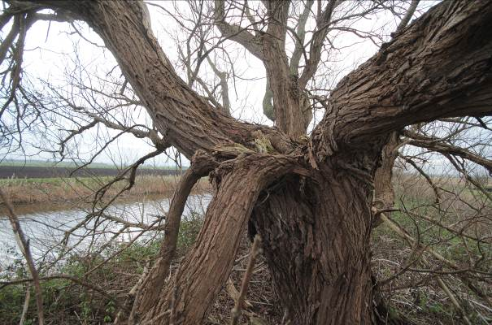
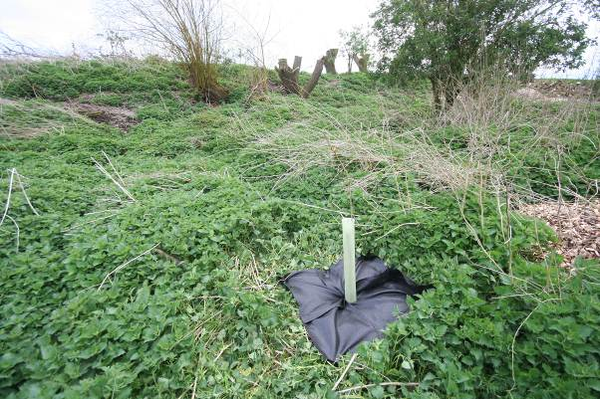
A riverside willow that was overdue for pollarding at Corney’s Farm.
A black poplar cutting planted at Corney’s Farm. In the background, pollarded willows.

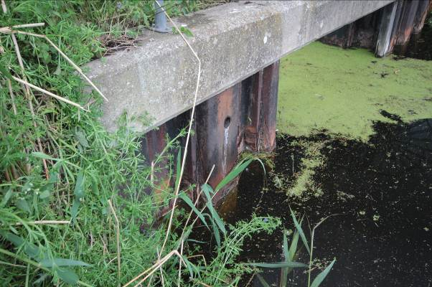
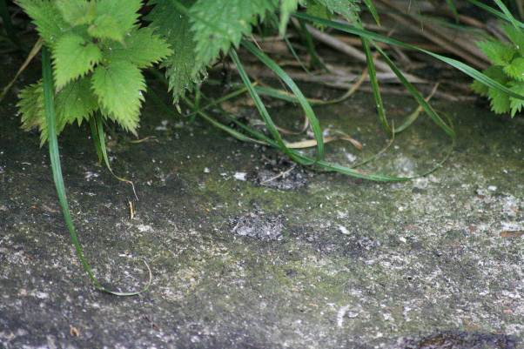
A hole was drilled in the sheet piles of Yaxley Fen Pumping Station on 30/05/14 to provide a potential nesting hole for kingfishers.
Otter spraints at the outfall of Yaxley Fen Pumping Station indicate their presence in the area.

Black Poplars
The Board’s target for planting black poplars (provide at least two sites for them in the District) has been achieved but if any Commissioners would like to provide a further site or sites for cuttings please contact me. They grow to be a distinctive, long-lived tree that was traditionally planted as a Parish or ownership boundary marker. It becomes more valuable to wildlife as it ages as well as being the UKs rarest timber tree.

The Middle Level Biodiversity Partnership meeting
A reminder that the next Middle Level Biodiversity Partnership meeting will be held on Wednesday the 3rd of December 2014 at the Oliver Cromwell Hotel, March. It is open to all members and staff of Boards and offers a morning of short but interesting presentations by guest speakers.

Previous subjects have included the internationally important Bronze Age discoveries in the fens, schemes that support farmland birds, the geology of the Middle Level area and the results of a water plants and beetles survey on six IDBs that showed the value of regular ditch maintenance for important species.

All members will be very welcome to attend and are sure to enjoy a stimulating morning.

Cliff Carson
Environmental Officer
31/05/14
Tel 01354 602965 Mobile 07765 597775

